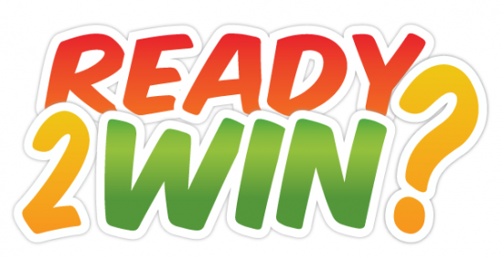

You’ve got the app, now get networking!
Are you ready to take the challenge? Log in to play for prizes and bragging rights – ZeristaHunt is THE game within the Zerista Live App! Use your iPhone, iPad or Android phone to scan QR codes wherever you see them in the exhibit hall, in sessions, and throughout the venue. Have fun, meet people and win great prizes!
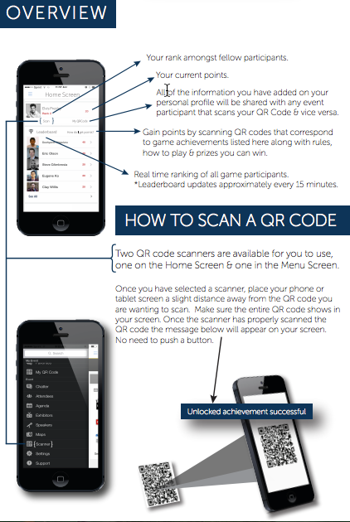
The following points you can begin earning at home before the conference even begins!
1. Complete/Update Your Profile - 50 points
2. Add an Agenda item to your Schedule - 5 points each
Hunt for QR codes around the show floor, venue and session rooms. Each code you scan earns points.
**Be Sure To Scan the QR codes to earn your points in the following ways:
3. Add an Attendee Contact to your Contact List by scanning their QR Code - 5 points each
4. Attend Keynote Presentations - 20 points each
5. Attend one of the Industry Expert Panels at 1:15 pm both days - 15 points each
6. Visit Association Booths (ISACA, ISSA, ACFE, TAG, (ISC)2, InfraGard) - 20 points each
7. Find the Mystery Exhibitor on the show floor during Day One - 35 points
8. Find the Mystery Exhibitor on the show floor during Day Two - 35 points
9. Visit Radware in booth 124 on the exhibitor floor and ask the representative their trivia question - 25 points
10. Start Your Day right with morning coffee - 7:30 am - 9:00 am near registration and Day One at booth 320 (ThreatTrack) at 9:00 am and Day Two booth 140 (Fidelis) - 25 points
11. Visit the Infused Water Bar Day One - 10:15am LockPath (booth 136) and DarkTrace (booth 318) & 2:15pm SecureAuth (booth 324) Day Two 10:15am - Zscaler (booth 304) & 2:15pm in the CyberLounge - 25 points each
12. Reboot with Complimentary Coffee - 2:15pm Day One: Trend Micro (booth 308) & Day Two: GuidePoint (booth 218) - 25 points each
13.Grab Complimentary Dessert - 2:00pm Day One: Forcepoint (booth 108) Day Two: AdvizeX (booth 417) - 25 points each
14. Visit the CyberLounge - 25 Points
15. Play a Game of CornHole at Booth 132 with Carbon Black - 35 points
16. Attend the Casino After-Party! Day one 3:45 pm - No need to play, enjoy snacks and beverages while socializing. Peak10 (booth 306) or play their sponsored Casino Table - 25 points
17. Test your luck at the Casino Tables visit Cisco (booth 142), Fidelis (booth 140), Radware (booth 124), Trend Micro (booth 308), SecureAuth (booth 324) - 25 points each
SOCIAL MEDIA
18. Post a comment on the Chatter and share to your social media platforms with event hashtag: #ZeristaLive - 5 points each (limited #)
19. Post a comment on the Chatter with a photo and event hashtag: #ZeristaLive and share to your social media platforms - 10 points each
How am I doing?
Check the leaderboard in the app to see how many points you have, and where you stand in the game. (Please note that the leaderboard updates approximately every 5 minutes)
Rules and Prizes
The top point earner will win a prize. If you earn at least 600* points, you will be entered into a drawing for two additional prizes - Good Luck!
*suggested total – can be changed.
Play fair!
We reserve the right to remove points that were obtained in a fraudulent manner.
Ready…set…GO ZeristaHunt!

